Ensuring Accuracy in Dynamic Network Environment
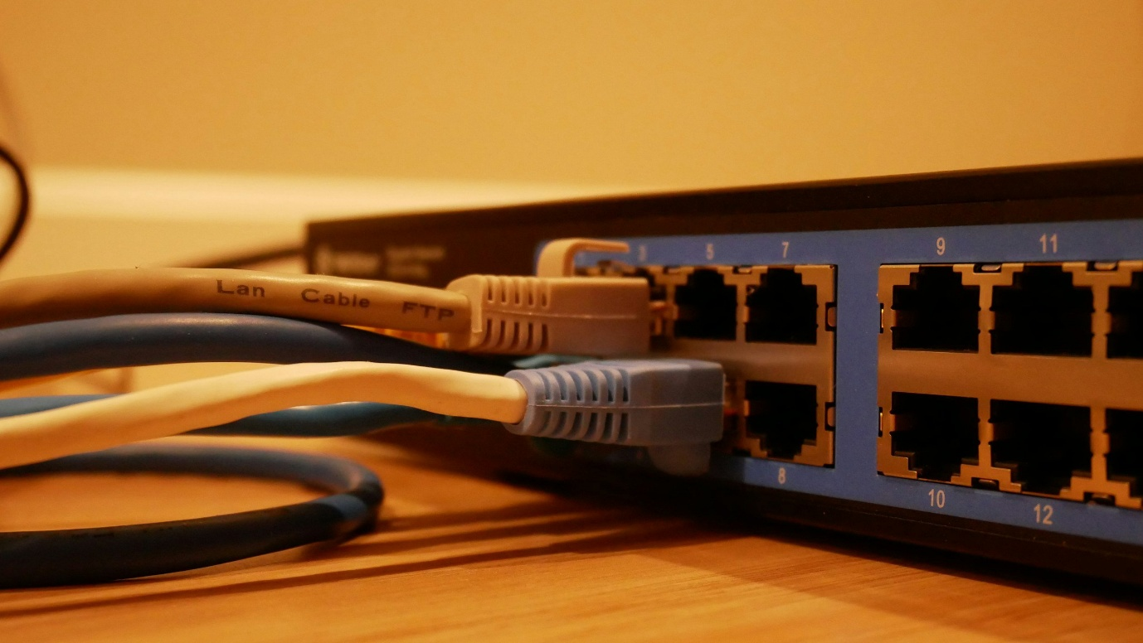
Context
A regional infrastructure provider managing a hybrid network stack of on-prem networking gear, cloud-managed routers, SD-WAN nodes etc. encountered a critical outage caused by an undocumented configuration change.
While documentation lagged and made it difficult to troubleshoot or verify what had actually shipped, engineers relied on Slack threads to recall who changed what and when. Version mismatches between product updates and client-facing documentation led to failed implementations and repeated support escalations.
Challenge
- Untracked changes leading to critical outages and version mismatch.
- Disjointed systems: markdown files, Slack logs, out-of-sync wikis
- Delays in incident resolution
- Failed client installations and audit risks
Our Approach
- 
Audit and Analysis
We initiated a systems-level documentation audit, starting with version control practices, change management workflows, and client-facing documentation flows.
Each undocumented change posed a traceability risk, so we focused on building modular doc components tightly coupled with product release cycles.
1. Internal, developer-facing docs were synced with production environments
2. Client-facing docs reflected only validated, installable releases
- 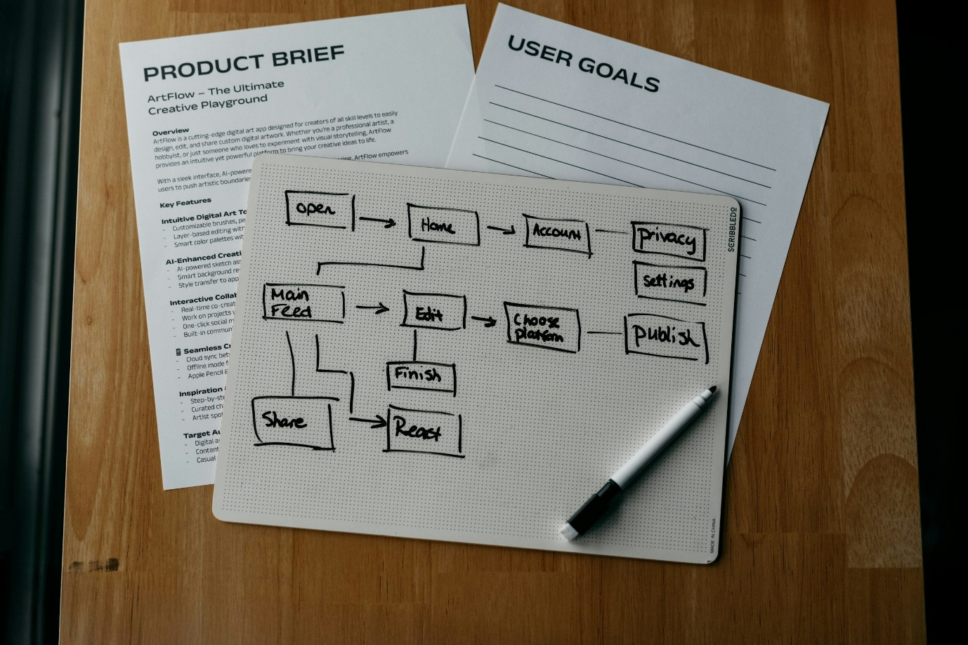
Implementation
1. Introduced Git-based changelogs linked to product and doc updates
2. Deployed modular documentation templates that ties each config change to an associated doc component
3. Synced customer-facing installation guides with release triggers using Azure DevOps pipeline
4. Implemented review protocols before any client-facing documentation was shipped
5. Established fallback audit logs for traceability support
- 
Outcome
Incident resolution time dropped by 45% as teams could trace config changes through clean documentation links. The number of failed client implementations due to doc-version mismatch fell to 0 over a 3-month period. The engineers reported reduced cognitive load during handoffs and escalations.
“We used to lose 2-3 hours per ticket just chasing down context about changes made weeks ago. Now, I can find the exact changes within minutes, trace them to the original update, and even reference the associated documentation.“ - Engineering Lead
Ensuring Accuracy in Dynamic Network Environment
Context
A regional infrastructure provider managing a hybrid network stack of on-prem networking gear, cloud-managed routers, SD-WAN nodes etc. encountered a critical outage caused by an undocumented configuration change.
While documentation lagged and made it difficult to troubleshoot or verify what had actually shipped, engineers relied on Slack threads to recall who changed what and when. Version mismatches between product updates and client-facing documentation led to failed implementations and repeated support escalations.
Challenge
- Untracked changes leading to critical outages and version mismatch.
- Disjointed systems: markdown files, Slack logs, out-of-sync wikis
- Delays in incident resolution
- Failed client installations and audit risks
Our Approach
Audit and Analysis
We initiated a systems-level documentation audit, starting with version control practices, change management workflows, and client-facing documentation flows.
Each undocumented change posed a traceability risk, so we focused on building modular doc components tightly coupled with product release cycles.
1. Internal, developer-facing docs were synced with production environments
2. Client-facing docs reflected only validated, installable releases
Implementation
1. Introduced Git-based changelogs linked to product and doc updates
2. Deployed modular documentation templates that ties each config change to an associated doc component
3. Synced customer-facing installation guides with release triggers using Azure DevOps pipeline
4. Implemented review protocols before any client-facing documentation was shipped
5. Established fallback audit logs for traceability support
Outcome
Incident resolution time dropped by 45% as teams could trace config changes through clean documentation links. The number of failed client implementations due to doc-version mismatch fell to 0 over a 3-month period. The engineers reported reduced cognitive load during handoffs and escalations.
“We used to lose 2-3 hours per ticket just chasing down context about changes made weeks ago. Now, I can find the exact changes within minutes, trace them to the original update, and even reference the associated documentation.“ - Engineering Lead

